Table of Contents
Started: 6/14/2023

Text Color Codes: 1
(6/14/2023) Literature Search 1
(06/14/2023) Installing Arduino IDE and NodeMCU Board 1
(06/14/2023) Installing the MyController.org Server (v1.5) on Windows 4
(07/25/2023) Setting up MyController v2.0 server on RPi 10
(07/26/2023) Dynamic DNS and Port Forwarding 16
(07/26/2023) Setting up an MQTT Sensor Node 17
(11/28/2023) Twilio SMS setup 19
(04/30/2024) Installing MC v 1.6 on windows 10 19
(01/04/2025) Setup Kincony ALR LoRa board for receiver mode on Windows 20
(01/21/2025) Setup LoRa transmission from Heltec board 22
(05/03/2025) Installation and Setup of Home Assistant OS 22
(05/03/2025) Remote HA Access 25
(05/03/2025) HA Application 26
(05/03/2025) Setup The Things Network for LoRa Comms 27
(mm/dd/yyyy) Setup HA for MQTT Comms 28
(05/03/2025) Setup SenseCap LoRa Gateway 28
(05/03/2025) Setup local WiFi devices on ESPHome 30
(09/06/2025) MQTT Sensor Setup 32
(mm/dd/yyyy) LoRa Sensor Setup 32
(09/06/2025) Install and Setup HA for Windows 32
(09/06/2025) Setup WisBlock Earthquake sensor 32
(mm/dd/yyyy) Setup Heltec LoRa Indoor Gateway 33
(mm/dd/yyyy) Connect Home HA to TTN 33
(mm/dd/yyyy) Template 33
(mm/dd/yyyy) Template 33

Text Color Codes:
Black - Normal text entry
Red - Important takeaways (ex. things to change going forward)
Blue - Continued to date
Green - Key results
Orange - File Paths
Purple - Unfinished Work

(6/14/2023) Literature Search
(Continued From:)NA

(06/14/2023) Installing Arduino IDE and NodeMCU Board
(Continued From:NA)

Install files such as drivers are available for download on Drive at Research/Weather Station/Drivers

The latest Arduino IDE software can be downloaded from (Download and install Arduino IDE – Arduino Help Center) based on the desired operating system.

Once installed, the correct libraries and boards must also be installed. For Arduino branded boards such as the Uno, Mega, Nano, and Micro, the necessary libraries are preinstalled when the software is installed. For the Wifi enabled NodeMCU (1.0) the library must be installed and the IDE must be directed to additional boards using the following url: (http://arduino.esp8266.com/stable/package_esp8266com_index.json).

For MacOSX AND Windows this is linked under <File <Preferences, and then entered into the “Additional boards manager URLs” field.

After adding the link, click OK and then click on the “boards manager” icon in the upper left side of the screen. A narrow side window will appear with a search bar at the top. Search for “ESP8266” and install the most current version of the boards manager.

Note: For the MySensors.org gateway to link using NodeMCU 1.0, you will likely need to downgrade to the ESP board library version 2.7.4 (the last version prior to v3.0.0)
For Windows, a USB driver for CP2102 will also need to be installed. It can be found at CP2102 Classic USB to UART Bridge - Silicon Labs (silabs.com), but is also included in the Drive folder (Research/Weather Station). Drivers for Mac are also included, but I don't remember if they were needed.
To install the driver for Windows, download the zip file to your downloads folder and extract it there. Open the device manager and find the unknown USB device, which will appear and disappear as you plug it in and unplug it. It will have the acronym “UART” also. Double click on the unknown device and then click to update the driver. Direct the computer to the specific location where you extracted the driver folder and click OK to install the driver. After it is installed, if it has been successful, the device should move to “Ports” and be listed as a Silicon Labs CP210x USB to UART Bridge on a specified COM port (ex. COM5). This is the COM port you will find the board on in your Arduino IDE to send programs, or sketches, to.

Under Tools - Board - ESP8266, you should be able to select the NodeMCU 1.0 board. If not, the board manager in Arduino IDE has not been setup correctly. If it is there, select it as shown in the screenshot below.
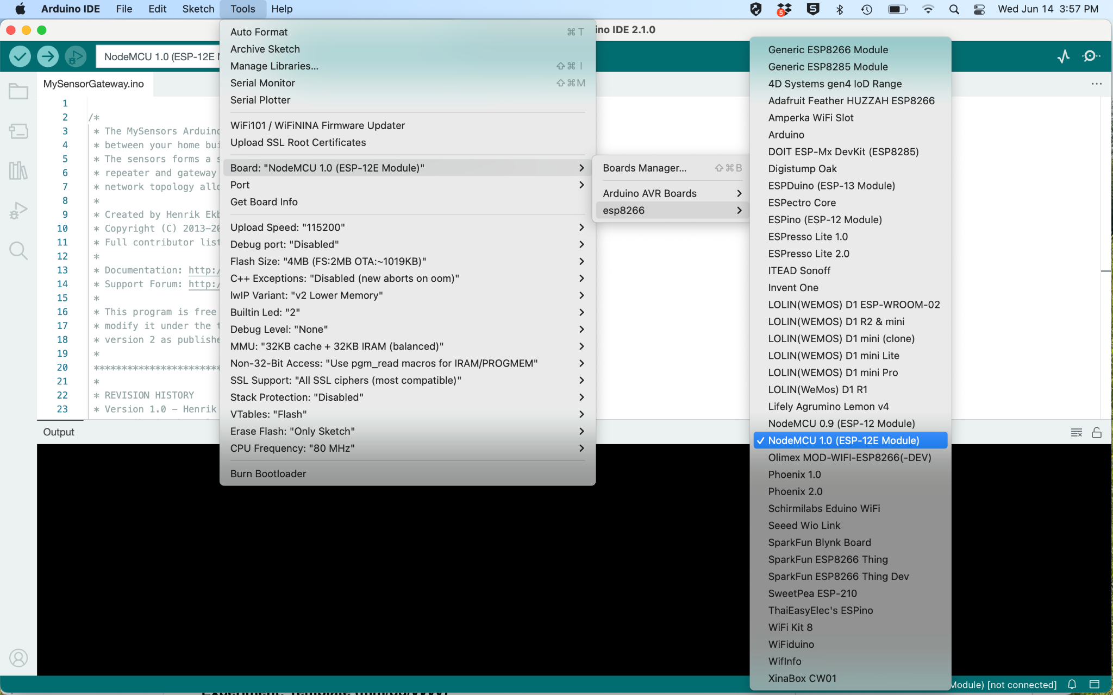

After the NodeMCU board has been selected, confirm the settings are as shown below from the Tools menu:
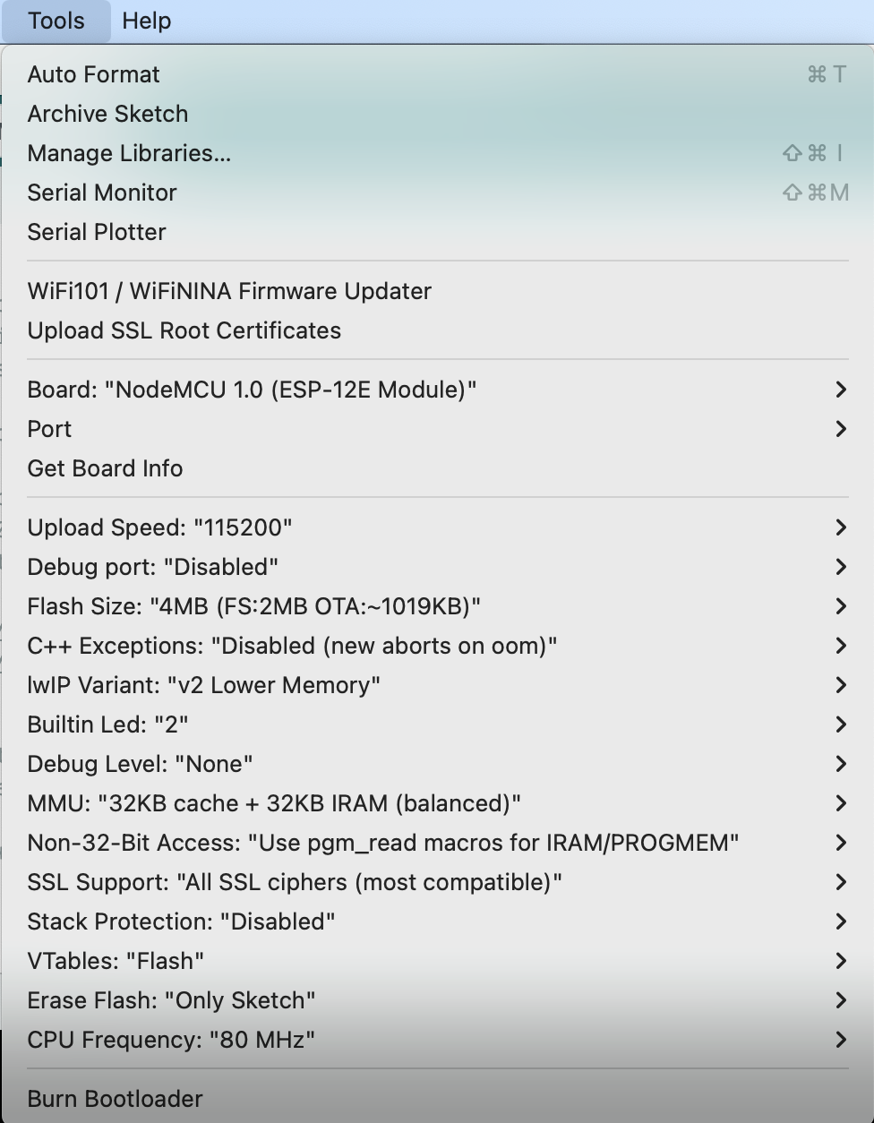

If the driver has installed correctly, you should find the board appearing under Tools - Port and on the COM port you noted in Device Manager (Windows) or as dev/cu.usbserial-001 (or something similar in MacOS). Once connected successfully, you should notice the following note in the bottom right of the Arduino IDE window:

You are now ready to send sketches (programs) to the NodeMCU board.

Note, that the serial upload speed may need to be changed depending on the baud rate your sketch sets for serial communication. Common baud rates include 9600 and 115200.
(Continued To: )

(06/14/2023) Installing the MyController.org Server (v1.5) on Windows

Install files for this work are included on Drive at: Research/Weather Station/MyController Server Files

From what I can tell, MyController.org and MySensor.org will only run on devices that support Java. This includes Windows, Linux, and RaspberryPi devices, but does not include MacOS. Make sure you have Java installed and updated before you continue.

Installing the MyController server on Windows 10, I followed the instructions provided by lukash535 at How to install my controller on windows. | MyController.org - The Open Source Controller Just in case it changes, I have copied and pasted the instructions below, along with images. I was able to follow the instructions and extract the NSSM package along with the MyController server install package directly to the C:/ directory without any subdirectories.

You can do this by adding a new service in Windows. It was not easy but the "NSSM - the Non-Sucking Service Manager" program came to the rescue.
With NSSM you can greatly simplify the configuration.
Important matters at the beginning:
• Unpack MyController to location that we will not change later because it will require editing or repeating the whole process of creating the service from the beginning.
• Download from the site https://nssm.cc and unpack the NSSM program to any place. After configuration process we will not need it anymore.
To make it easier I unpacked it directly onto the drive C:\
So step by step:
- Click the start button and enter cmd.exe in the search box. Then, after right-clicking the properties menu, we choose to "Run as an administrator" (unfortunately my windows is in Polish)
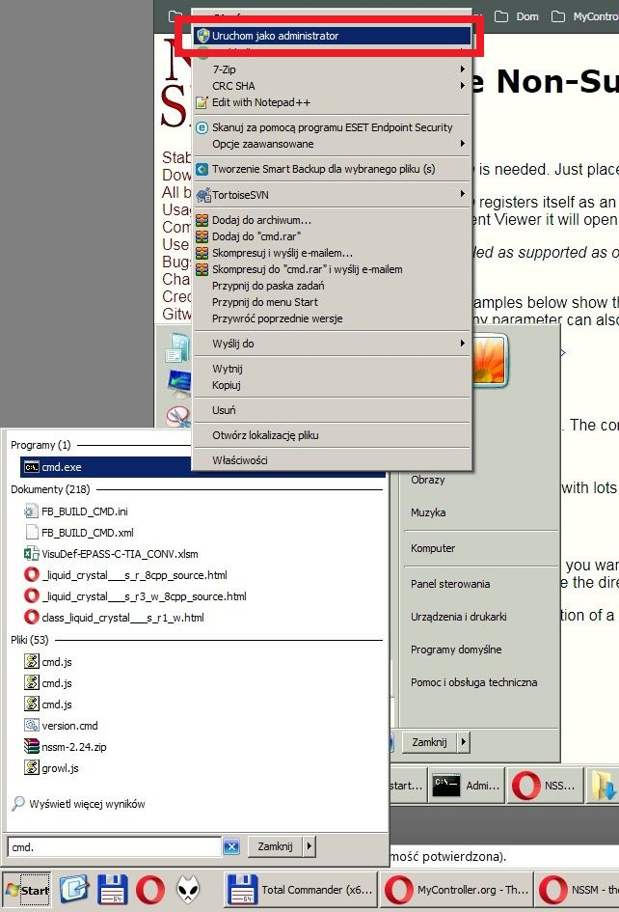
- Next, we run the nssm.exe program with the install parameter
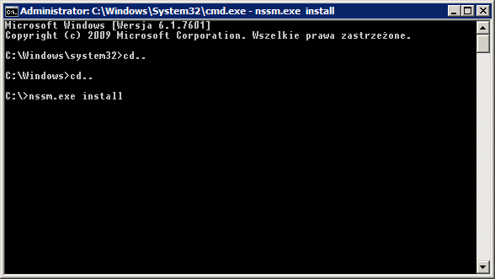
- A new window opens. We select the path to the start.bat file in it and set the startup parameters. In the "shutdown" tab, I tried to set the timeout for 10s in all options, it seems to me that only the first option "Generate control-C" is important to us.
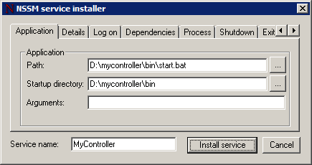
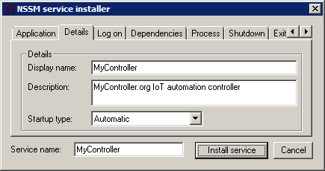
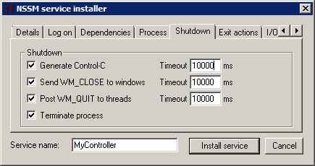
- Now we can check if the new service has appeared on the list. To do this, we launch the "Services" application from the start menu.
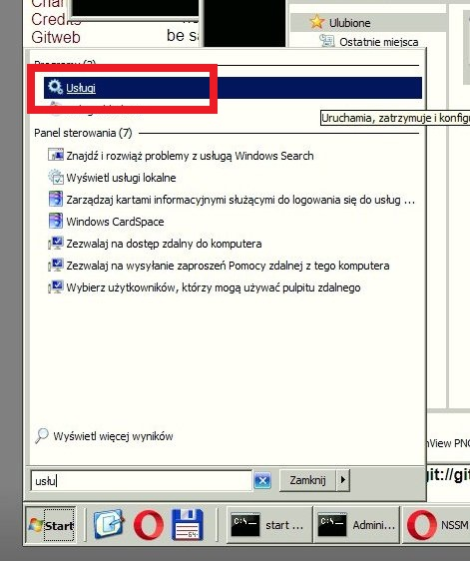
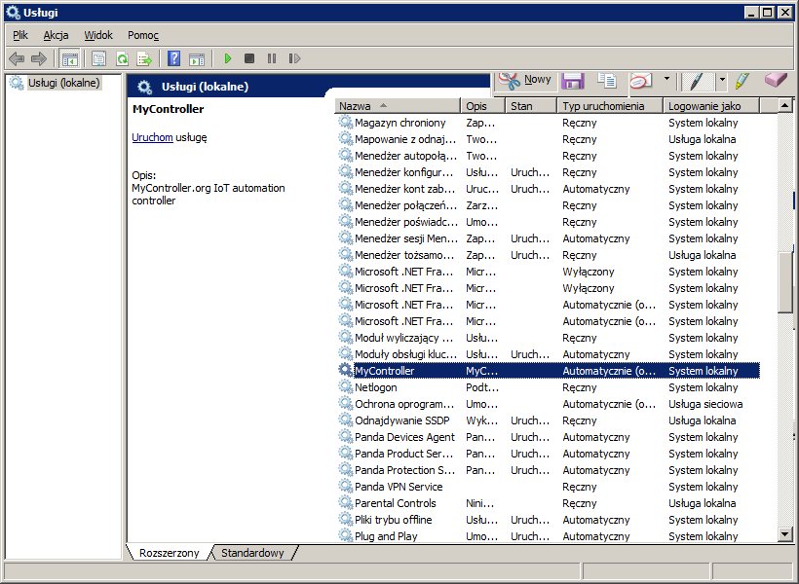
- Now we can try out whether our service will start properly. IMPORTANT! If you have the mycontroller server running directly from the start.bat file, please close it first!
To controll service you can use button from green frame on screen (Run, Stop, Hold on, Resume).
In red frame you can check status. If everything is ok it should be "Running" (...or something like this)
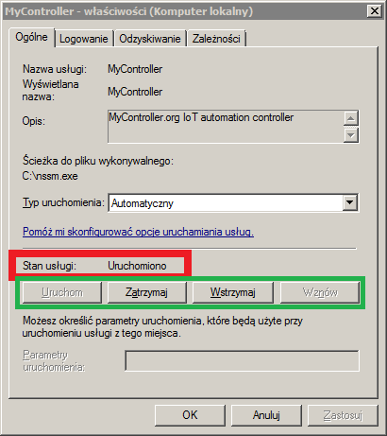
- The last test is to restart the computer without logging into Windows. Then try to launch the MyController page on another computer or phone.

I’m not sure exactly how to test this from another computer yet, but I was able to get the server to start after restarting the computer several times and checking in the Services window as the instructions suggest.

(Continued To: )

(07/25/2023) Setting up MyController v2.0 server on RPi
(Continued From:)
- Install Raspberry Pi OS 64-bit
- Start and setup with necessary updates
- Open Terminal and Web Browser
- In Web BRowser, go to www.mycontroller.org, www.forum.mycontroller.org, and https://get.docker.com
- In www.mycontroller.org, click on "Documentation" and navigate to "Install Docker"
- In terminal activate root user by typing
- sudo su

- Install Docker
- Begin installation of Docker by typing the following commands one at a time with enter after each
- curl -fsSL https://get.docker.com -o install-docker.sh
- cat install-docker.sh
- sh install-docker.sh --dry-run
- sh install-docker.sh (this one may take a few minutes, wait for "root@raspberrypi:/# to reappear)
- usermod -aG docker admin (if your non root user is "admin")
- systemctl enable docker.service
- systemctl start docker.service
- systemctl is-active docker.service (should return "active")

- So that you are able to move your server from location to location, you will need to setup a Docker network to manage the changing IP addresses
- Setup a Docker network to make your MyController Server Portable
- Enter the following in terminal:
- docker network create mycontroller

- Install InfluxDB
- Follow the instructions under "Install InfluxDB" for installation within Docker at www.mycontroller.org
- Enter the following text commands in terminal with enter after each.
- 1.(this one may take a few minutes, wait for "root@raspberrypi:/# to reappear)
- mkdir -p /opt/apps/influxdb
- cd /opt/apps/influxdb

- docker run --rm influxdb:1.8.4 influxd config > influxdb.conf

- Open File Manager and navigate to /opt/apps/influxdb/influxdb.conf, double click to open and verify that it has roughly 150 lines of text in it.
- In Terminal type
- nano /opt/apps/influxdb/influxdb.conf (this should open the same file in terminal and allow you to edit it)
- Using the up and down arrows, scroll down to the line that reads "[monitor]" and change the following from
- store-enabled = true to store-enabled = false
- press control-O followed by enter to save
- press control-X to exit the nano editor
- Enter the following into terminal
- 1. (to return to the highest level of the file directory)
- cd /
- 2. (this one may take a few minutes, wait for "root@raspberrypi:/# to reappear)
- mkdir -p /opt/apps/influxdb/influxdb_data
- cd /opt/apps/influxdb

- docker run --detach --name mc_influxdb \
- --network mycontroller \
- --publish 8086:8086 \
- --volume $PWD/influxdb_data:/var/lib/influxdb \
- --volume $PWD/influxdb.conf:/etc/influxdb/influxdb.conf:ro \
- --env TZ="America/Chicago" \
- --restart unless-stopped \
- influxdb:1.8.4
- 3. Verify that the influxdb container is running in docker with the following code in terminal
- docker ps (this should show a list of running containers, only influxdb should appear right now)

- To see the Docker logs type in the following
- docker logs mc_influxdb
- To stop the influxdb in docker typle
- docker stop mc_influxdb
- To restart the influxdb in docker type
- docker restart mc_influxdb
- To uninstall influxdb in docker type
- docker stop mc_influxdb
- docker rm mc_influxdb

- Install natsio
- At www.mycontroller.org go to "Install natsio" and follow the directions as follows
- Type the following into Terminal
- 1.
- cd /
- 2. (this will cause the Pi to download a few different things and install them, it can take a few minutes)
- docker run --detach --name mc_natsio \
- --network mycontroller \
- --publish 4222:4222 \
- --env TZ="America/Chicago" \
- --restart unless-stopped \
- nats:2.2.2-alpine
- 3. Verify that the natsio container is running in docker with the following code in terminal
- docker ps (this should show a list of running containers, only influxdb and natsio should appear right now)

- To see docker logs type the following
- docker logs mc_natsio
- To stop natsio type
- docker stop mc_natsio
- To restart natsio type
- docker restart mc_natsio
- To uninstall natsio type

- Install MQTT Broker in Docker
- at www.mycontroller.org navigate to "Install Mosquitto MQTT Broker" and follow the instructions as follows
- In terminal type the following commands to install the broker in docker
- 1.
- # create mosquitto.conf
- mkdir -p /opt/apps/mosquitto
- cd /opt/apps/mosquitto

- cat << EOF > mosquitto.conf
- allow_anonymous true
- persistence false
- persistence_location /mosquitto/data/
- EOF
- 2. (Pi will download some files which could take a little while)
- mkdir -p /opt/apps/mosquitto
- cd /opt/apps/mosquitto

- docker run -d --name mc_mosquitto \
- --network mycontroller \
- --publish 1883:1883 \
- --publish 9001:9001 \
- --volume $PWD/mosquitto.conf:/mosquitto/config/mosquitto.conf \
- --restart unless-stopped \
- eclipse-mosquitto:1.6.9
- 3. Verify that the MQTT container is running in docker with the following code in terminal
- docker ps (this should show a list of running containers, influxdb, natsio, and MQTT should appear)

- To see docker logs type the followings
- docker logs mc_mosquitto
- To stop MQTT broker type
- docker stop mc_mosquitto
- To restart MQTT broker type
- docker restart mc_mosquitto
- To uninstall MQTT broker type
- docker stop mc_mosquitto
- docker rm mc_mosquitto

- Installing MyController Server v2.0
- AT www.mycontroller.org, navigate to "Install with container image" and follow the directions as follows
- Return to the root directory by typing "cd /" into terminal
- In terminal type the following commands to install MC v2
- 1.
- mkdir -p /opt/apps/mycontroller/mc_home
- mkdir -p /opt/apps/mycontroller/mc_home/secure_share
- mkdir -p /opt/apps/mycontroller/mc_home/insecure_share
- 2.
- cd /opt/apps/mycontroller

- curl https://raw.githubusercontent.com/mycontroller-org/backend/v2.0.0/resources/sample-docker-server.yaml \
- --output mycontroller.yaml
- 3.
- nano /opt/apps/mycontroller/mycontroller.yaml

- Like earlier, the nano command is a terminal-based text editor and you will see a file with many lines of text open in terminal.
- At the top you should see a line that reads something like
- "secret: 5a2f6ff25b0025aeae12ae096363b51a # !!! WARNING: CHANGE THIS SECRET !!!"
- The alpha-numeric secret must be changed to anything with 1 to 32 characters, but remember what you pick.
- Change the yaml file so the database for influxdb points to your machine's IP address as follows:

- bus:
- type: embedded
- topic_prefix: mc_server
- server_url: nats://mc_natsio:4222
- insecure: false
- connection_timeout: 10s

- metric:
- disabled: false
- type: influxdb
- uri: http://mc_influxdb:8086
- token:
- username:
- password:
- organization_name:
- bucket_name: mycontroller
- batch_size:
- flush_interval: 5s
- query_client_version:

- click control-o to save followed by enter
- click control-x to exit nano

- Start your MyController Server by entering the following text into terminal:
- docker run --detach --name mycontroller \
- --network mycontroller \
- --publish 8080:8080 \
- --publish 8443:8443 \
- --publish 9443:9443 \
- --volume $PWD/mc_home:/mc_home \
- --volume $PWD/mycontroller.yaml:/app/mycontroller.yaml \
- --env TZ="America/Chicago" \
- --restart unless-stopped \
- docker.io/mycontroller/server:2.0.0

- In your web browser, check to make sure your server is running by going to http://<your ip>:8080 (ie. http://192.168.0.88:8080)
- This should bring up a MyController login screen where your username AND password are both set to "admin"
- Login to verify that it is working.

- On system restart, resume docker containers with the following commands in terminal
- docker restart mc_influxdb
- docker restart mc_natsio
- docker restart mc_mosquitto
- docker restart

(Continued To: )

(07/26/2023) Dynamic DNS and Port Forwarding
(Continued From:)
- If you would like to access the server from remote locations, you should setup a Dynamic DNS service that will provide a fixed URL rather than an IP address
- My Netgear router came with a single DDNS through www.noip.com, so I used that
- I first logged into my router from my local network at 192.168.0.1 followed by the login credentials
- There was a setting in the advanced options that allowed me to utilize a predefined DDNS service and I went with that, it was very easy to follow the instructions and connect to two devices (my router to the DDNS)
- My URL is http://wint0178.mynetgear.com:8080

- You will also need to setup port forwarding on your router to make sure traffic on the various network ports actually makes it into your server station
- My netgear router can be found on my home network at 192.168.0.1 and then use the login credentials to gain access
- I setup port forwarding using the advanced settings
- I opted to setup HTTP, TCP/UDP port forwarding to my RPi IP address (192.168.0.88) on ports 8080 (this is the Web interface you will log into remotely) and 1883 (this is the MQTT Broker)

(Continued To: )

(07/26/2023) Setting up an MQTT Sensor Node
(Continued From:)
- Open Arduino IDE and verify that you can connect to the NodeMCU board (v2.7.4) and have the MySensors library installed.
- Connect the board and select the correct port
- Open the example sketch <File<Examples<MySensors<GatewayESP8266MQTTClient
- Rename the sketch so you can make changes
- Open the MyController Web interface at http://<your IP address>:8080 and login
- Navigate to the Gateways tab on the left menu and click “Add” in the upper right corner
- Setup the MQTT Gateway as follows substituting your own Broker IP address as needed, but keeping the port (1883) the same:
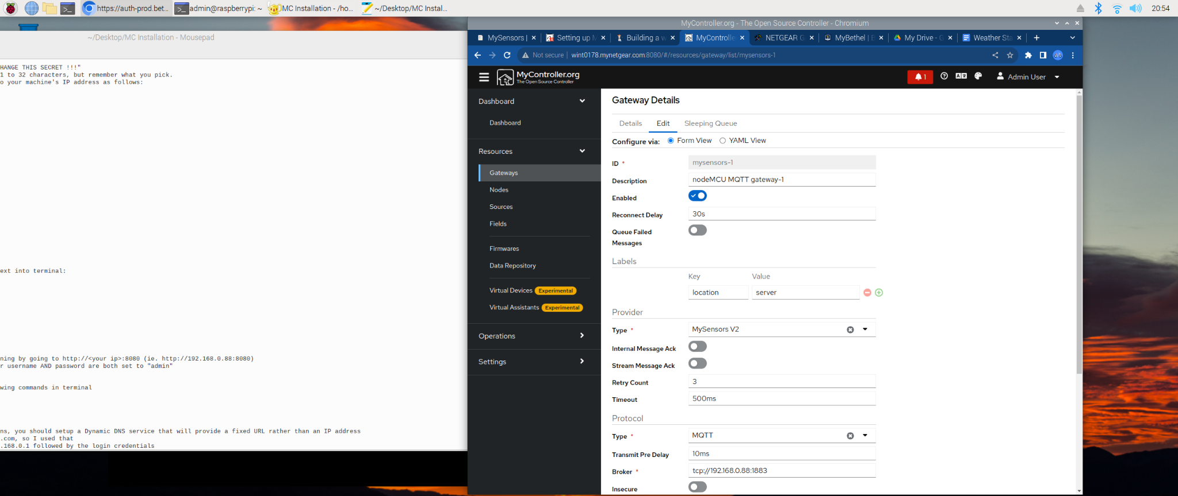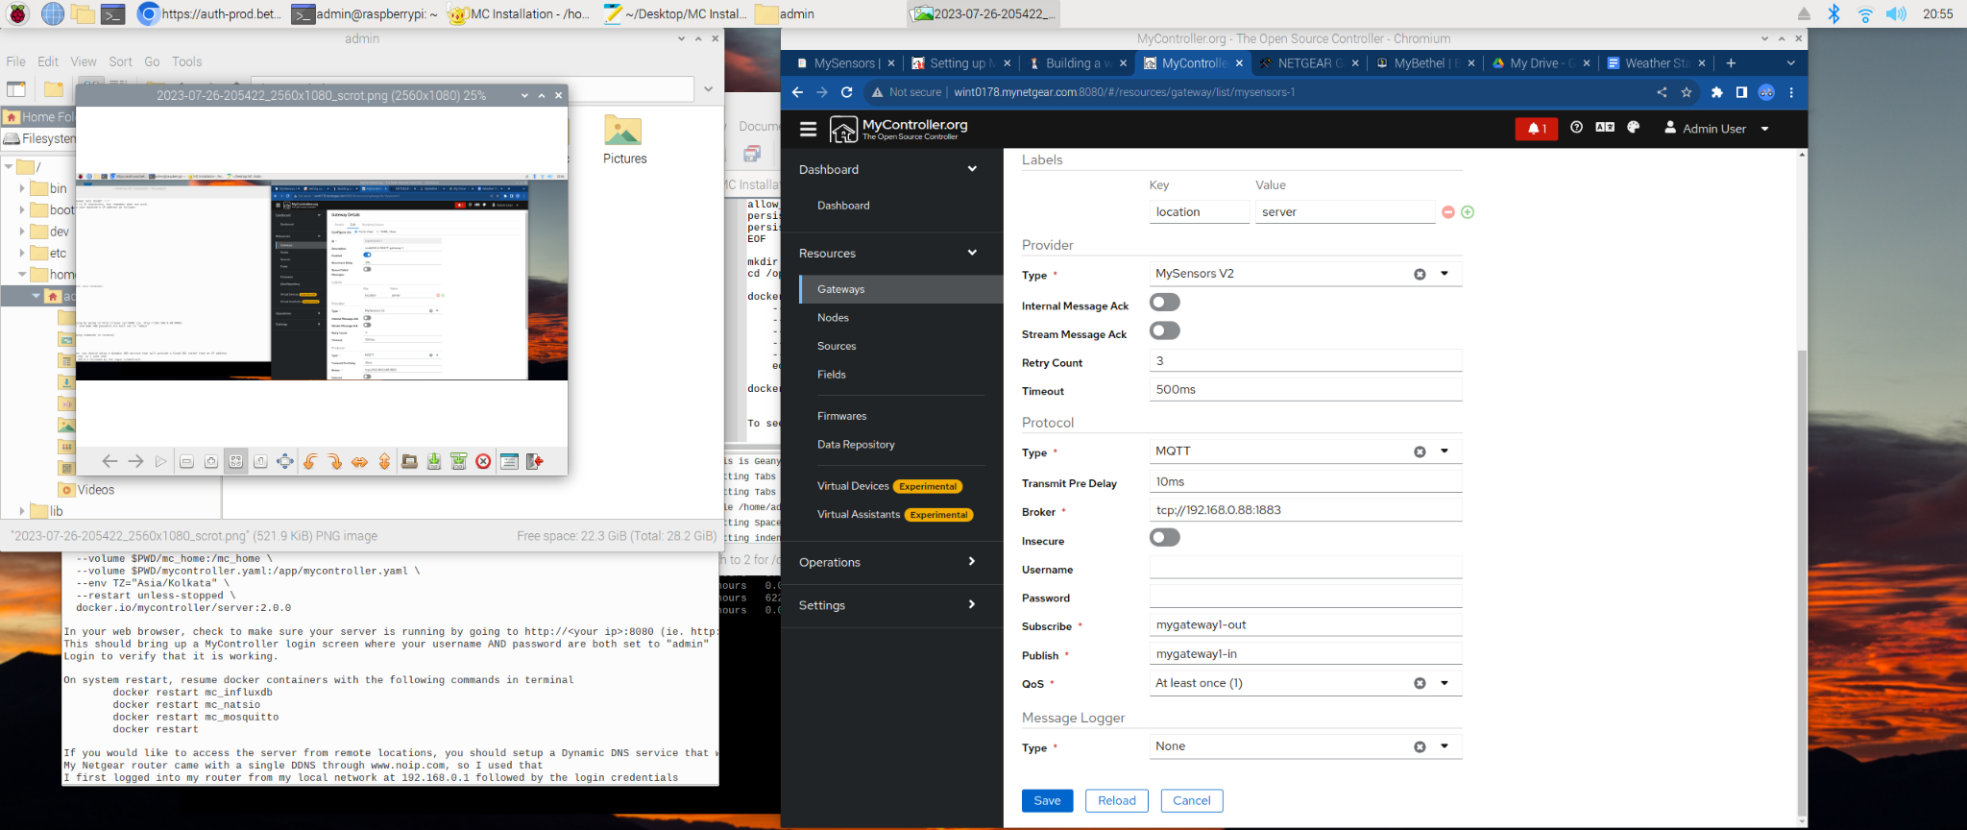
- Note that the ID, Subscribe, and Publish lines were all set up in Arduino and these must match what your arduino sketch set for each specific gateway.
- Also, the Subscribe line should read, as an example for gateway #1, “mygateway1-out/#” or it will not connect. The “/#” is essential.
- Click Save
- In Arduino IDE, adjust the settings as follows:

(Continued To: )

(11/28/2023) Twilio SMS setup
(Continued From:)
I created a Twilio account and added $20. The recovery code, in case I lose my cell phone for two-factor authentication is: JVRDG549HMZQ851S4S7E3X9M.

(Continued To: )

(04/30/2024) Installing MC v 1.6 on windows 10
(Continued From:)
I am working on installing a newer, unreleased, version of MC server on a Windows 10 laptop to fix a database issue with v1.5 at home. I got the link for the software download directly from Jeeva Kandasamy (he created MC) and downloaded it to my computer. I extracted it directly to the C: drive, which left a folder named “mycontroller” on the drive with all of the necessary files in it. I started command prompt as administrator and then changed to C: directory. Next, I attempted to start the .bat file using the following code:
C:\mycontroller\bin\start.bat, but but got this error:

C:\>java -Xms32m -Xmx256m -Dlogback.configurationFile=../conf/logback.xml -Dmc.conf.file=../conf/mycontroller.properties -cp "../lib/*" org.mycontroller.standalone.StartApp 1>../logs/mycontroller_console.log 2>&1
The system cannot find the path specified.

I went to java online and searched for a 64 bit version. Downloaded and installed this and then restarted the PC. The same error comes up. I also tried right clicking on the start.bat file and running as administrator, a tmp folder appears in the same directory (bin), but then Windows asks if I want to allow the app, CMD, to made changes to the device, I click yes. I can see the command pop up and run before automatically closing the window. The first time I tried this, there was also a Windows firewall request, but I approved it. That’s it. Nothing appears at localhost:8080.

(Continued To: )

(01/04/2025) Setup Kincony ALR LoRa board for receiver mode on Windows
(Continued From:NA)

Power your new Kincony ALR board using a 9-24 V DC power supply. Connect the white striped wire to ground and the black wire to power.

Connect the LoRa antenna using the SMA screw connector on the top, middle of the board.

Connect the WiFi antenna to the ESP32 chip with the snap on micro SMA connector directly on the ESP chip.

Power the ALR board on by plugging into the wall.

The board is now ready to connect using the built-in USB-C port. My Windows machine appeared to already have the UART to USB driver loaded, but if you do not see the chip appear as a COM port in Device Manager, you may need to install the latest firmware for Espressif. It is also described above as the CP210X Universal Windows Driver.

Navigate to Tools | Espressif Systems and download the ESP Download Tool. Once downloaded, extract it to your downloads folder and run the *.exe file to start the software.

Download the Kincony firmware for ALR to act as a receiver found at ALR LoRa firmware for home assistant enabled AUTO DISCOVERY, this is what you will use the ESP download tool software to load onto your ALR board.

Load the RECIEVER firmware using the ESP download tool as described at ALR LoRa firmware for home assistant enabled AUTO DISCOVERY

Confirm you have WinZip or equivelant software installed on your Windows machine because you will need it to extract the *.rar file for UARTAssist, which will allow you to change the json file on the board to update the WiFi and MQTT credentials of your system. You can download the UARTassist at Uartassist is a powerful serial debugging assistant with strong practicability. There is also a link for this download on the Kincony forum page that these instructions have been following.

Extract the downloaded file into the downloads file using WinZip. Run the extracted .exe file and connect to the ALR board at 921600 baud. Once you have adjusted the other settings to match the Kincony forum, click “open” and you should see the following message confirming that you are connected to the LoRa board: begin LoRa Initializing OK!

In the data send field add the following and adjust to match your system settings:
{
"wifi_name":"NETGEAR13",
"wifi_psw":"smilingcoconut656",
"mqtt_ip":"wint0178.mynetgear.com",
"mqtt_port":"1883",
"mqtt_user":”databroker",
"mqtt_psw":"password"
}

Once I reflashed the board (the first time didn’t seem to work) and then adjusted the settings above by removing the “http://” from the mqtt_ip, I was able to get the ALR to connect to either the wint0178.mynetgear.com server (located in Woodbury, MN when I am working in Quito) or my local server at “homeassistant.local”. Once all of this happened, the ALR display showed the mqtt connection status along with the LoRa signal level. The ALR board also appeared in HA as a new device and automatically added all of the I/O channels to the Overview dashboard of HA. With the UART assistant still open, I was able to see each time I tried to toggle the relay on the ALR board and the commands would come through to the UART display even though the relay itself didn’t appear to change state.

Next, I will need to try getting one of the Heltec LoRa boards programmed to read data from something simple like a BME280 board and send it to the ALR board.

(Continued To:NA )

(01/21/2025) Setup LoRa transmission from Heltec board
(Continued From:NA)
The heltec boards need to be loaded into Arduino IDE

I started by installing heltec_unoffical and LoRaWAN_ESP32 libraries for Arduino. Then, I pulled up the example sketch Examples<Heltec_ESP32_LoRa_v3<LoRaWAN_TTN. With the correct board and port selected, I also changed the region to US under Tools in the Arduino IDE.

I uploaded the sketch to the Heltec board and then was able to get a request back from the board in the serial monitor. The request was to establish the radio frequency along with various ID numbers and Keys. These include the following:

Band (EU868 or US915)
Subband (this does not appear to be needed)
joinEUI (16 hex characters, but it seems all zeros should work)
devEUI (16 hex characters that I generated at a website for this purpose)
appKey (32 hex characters
nwkKey (32 hex characters

I think the appKey and nwkKey may need to be generated by the ALR LoRa Gateway, but I’m not sure about this and I don’t know how to find them on that device.

(Continued To: )

(05/03/2025) Installation and Setup of Home Assistant OS
(Continued From: NA)
Home Assistant is the “controller” application that will be used to collect sensor data from various types of home-built and smart home sensors. This is like a highly customizable version of Alexa. It will be run on a dedicated computer such as a raspberry pi, but you need not have a display for access to the system, so it can be installed in your media or IT cabinet/closet with wired connection to your local router AND with internet access.

For this installation, I will use a Raspberry Pi 4 (RPi4) with a 32 GB SSD and it will be hooked up to my WiFi router via ethernet.

Installation of the HA OS
- Download and install the application “Raspberry Pi imager” to your Windows or Mac computer.
- Into the reader/writer slot of your computer, insert the micro SD card you intend to run HA-OS from. In other words, mount the drive to your computer.
- In the imager application window on your computer, select the specific model of RPi you will utilize (For this instance RPi4).
- From the Operating Systems dropdown menu select “Other specific-purpose OS” → “Home assistants and home automation” → “Home Assistant” → the version you intend to use, which for all RPi systems not furnished direction from Home Assistant, pick the “Home Assistant OS” at the top of the list, which should also reflect the specific hardware you already selected.
- Under “storage” select the mounted SD card you intend to use.
- Click “Next” and confirm that the drive will be completely erased.
- Wait for the installation process to complete, which you will know when the software says you may remove the drive.

Starting HA-OS for the first time:
These instructions also work for moving an already installed instance of HA-OS to a new location with new internet and WiFi credentials.
- With your RPi off and disconnected from all cords, insert the SD card with the HA-OS image installed.
- Connect your RPi to your internet router via ethernet cable and plug the RPi into power. Allow several minutes for it to startup for the first time.
- In a web browser connected to the same router (whether through WiFi or ethernet should not matter, but connected via ethernet cable is advisable if your first attempt to connect via WiFi is unsuccessful) navigate to http://homeassistant.local:8123/, which should open the login page for your new HA instance. If this also doesn’t work, connect the RPi running HA to an HDMI monitor and record the local IP address. It will be something like 192.168.xx.xx and you will be able to connect to the HA instance at http://192.168.xx.xx:8123.
- If you are not able to connect to your HA instance, you may need to setup port forwarding in your router administrative settings. This varies between manufacturers, but should be found under advanced settings for your router admin page (These are often found at http://192.168.1.1 or http://192.168.0.0 and it may be listed, along with the admin username and password, on the bottom of your router). See the picture below for settings that worked on my Netgear router:
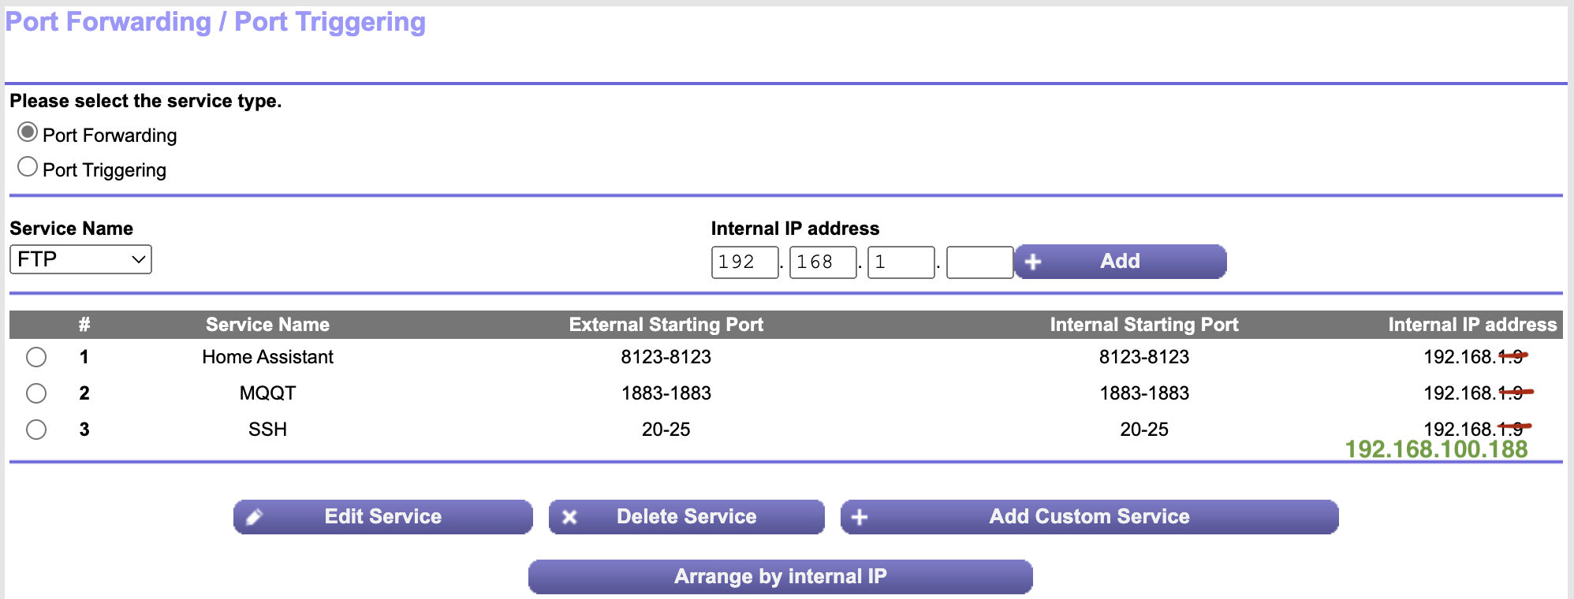
Note that you will need the specific internal IP address of your RPi, which can be found in the list of attached devices. Also note that two other services, mqtt and SSH are also setup in the image above. These may be useful for you later for WiFi transmission of sensor data coming from other networks (mqtt) and for file/terminal access to your HA instance for advanced user settings (SSH)
- For new installations: follow the account setup instructions so you may gain access to your HA from your local network. Note that your username will always be in all lowercase letters even if your “name” is not.
  - For relocations, enter your credentials and login to your HA system.
- If you plan to connect your RPi running HA-OS to your network via WiFi, scroll to the bottom of the left-hand menu and enter “Settings”. Then go to “System”, “Network” and fill the correct credentials for your WiFi network under WLAN0.
- No network configuration is necessary for ethernet connected systems.
- In this same “Network” screen, change the name of your HA instance, as it will appear on your local network, if you like.
- You can now access your HA instance on your local network, within the Home Assistant App (again only from your own home network) or send WiFi enabled sensor data to your HA instance at http://homeassistant.local:8123/ or at your local IP address as follows (for example) http://192.168.1.9:8123

Introduction to HA-OS
- There is a huge body of information about HA available online and a large and very well-developed community of people committed to development, support, and forums.
  - Home Assistant documentation: https://www.home-assistant.io/
  - Home Assistant community forum: https://community.home-assistant.io/
- It is highly advisable that each user begin their journey with HA by digging into the available resources online. Consider starting with the following:
  - Onboarding, which is mostly what you have already done to this point. https://www.home-assistant.io/getting-started/onboarding/
  - Introduction to concepts, terminology, HA vernacular, … https://www.home-assistant.io/getting-started/concepts-terminology/
  - Continue digging into other details as your own needs and interests dictate.

(Continued To: )

(05/03/2025) Remote HA Access
(Continued From:)
- If you would like to have access to your HA instance when you are away from home, there are many ways to accomplish this, including via DDNS (custom web URL, typically pay-for-service), VPN (private “tunnel” to your instance, can be free or paid), Cloud-based (a combination of the two previous examples, but is easiest to implement).
- DDNS: Your router may be able to connect with a Dynamic DNS site out of the box. For my Netgear router, it was able to connect with www.NOIP.com and integration was pretty seamless. I was able to select my own sub-domain under several of their available domains and link it to my public IP address. To find your public IP address, start my visiting www.whatismyip.com and recording your IPv4, which will be formatted something like 123.456.78.90.
- VPN: In your HA instance, navigate to Settings→Add-ons→Add-on Store and search for TailScale, follow the included documentation to install and setup your VPN connection.
  - You will need to setup a TailScale account on their website and then you can also install the TailScale app on your phone, tablet, or computer.
  - Each device connected to your TailScale will be given a private IP address and, when connected to TailScale, you will be able to connect “through” to your HA instance from anywhere.
- HA Cloud: This can be done in a number of different ways, but it is fully integrated out-of-the-box with NabuCasa, which can be tested for 30 days without cost and without providing payment information (no worry about forgotten subscription fees) and it currently costs $65 per year.
  - To setup, navigate to Settings→Home Assistant Cloud and setup your account and settings following the instructions. You will need to turn on “remote access” once you have this setup, which will provide you with a public url where you can access HA remotely.

(Continued To: )

(05/03/2025) HA Application
(Continued From:)
The simplest way to access your HA instance is using the application, but it is always available through a web browser also. If you would like to have access to multiple HA instances, it is likely advisable to utilize the application since it can store the login credentials for each instance simultaneously.
- Search for and install the Home Assistant app in your devices application store. The application icon, to differentiate between other similar applications, should look similar to the image below:

- Once you have the application installed, open it and follow the instructions to sign in. This is typically easiest when your device is on the same WiFi/LAN network as the HA instance you are attempting at access. You may use either of the local access links provided above to access your instance from its home location.
- The application is able to manage the internal and external access url for each instance of HA you plan to access. Change these, specific for each HA instance’s internal and external urls, by accessing the settings as follows:
  - For MAC - Home Assistant→Preferences→Servers and select the specific instance you want to modify
  - For iOS (iPhone or iPad) - In the left-hand menu bar navigate to Settings→Companion app and select the specific instance you want to modify
- To use the internal URL and have access using the external URL when away from home, each server will need stored the local WiFi login credentials under the “Internal URL” settings. Otherwise they can all be accessed from the same internal url http://homeassistant.local:8123
- Once internal access as been setup, navigate to “external url” and enter the specific external access credentials you setup earlier (DDNS, VPN, Cloud,...)
- When both are setup, your application will only use the internal url to access the HA instance when it is on the specified WiFi network and will default to the external url in all other cases.
- To switch between different HA instances (ie. different RPi servers running separate HA systems) you can return to this same page in settings and select a different instance and click “Activate” or:
  - For MAC - select the other instance from the available dropdown menu in the upper right corner of the application window.
  - For iOS - three-finger swipe left and right to switch between instances.
  - For Web browser - simply save the different external URLs as favorite sites.

(Continued To: )

(05/03/2025) Setup The Things Network for LoRa Comms
(Continued From:)
For radio communication from remote sensors back to HA, you will need to setup a LoRa server and gateway access. This can be done using any number of services and devices, but I have used The Things Network (TTN) and compatible devices exclusively.
- Set up a free account at https://console.cloud.thethings.network/ following the instructions provided.
- When requested, select the appropriate server cluster, which is more than likely North America (nam1).
- Once you are logged in, this service will connect your LoRa sensors to your specific HA instance through any LoRa gateway, even those you don’t personally setup and manage. A map of available gateways, for free, public use, can be found at https://ttnmapper.org/heatmap/
- If you want or need to setup another Gateway, you will so this in the Gateway table of TTN console home. See Setup SenseCap LoRa Gateway for more information about setting up a specific LoRa gateway.
- In order to connect your HA instance to TTN, you will need to create an application in TTN Console. Documentation can be found at https://www.home-assistant.io/integrations/thethingsnetwork/
  - Click the “Add Application” button.
  - Create an application name with all lowercase letters and dashes, keep is short (ie. homeassistant-home).
  - Create a friendly name for your application which can contain spaces and capital letters (ie. HA Home).
  - Provide a description and click “Create”.
  - In the left-hand menu bar, click on “Message Storage” and active message storage so that incoming sensor data will ‘live’ long enough to be sent to your HA instance.
  - Within the application, click “API Keys” in the left-hand menu and then click “Add API Key”.
  - Enter a name and expiry date for the API key, this date can be changed later but should give you time to make sure it is all working, start with at least one month.
  - For simplicity, check “grant all current and future rights” and then click “create API Key”.
  - Create a text document that will contain all of the API keys you generate for applications, gateways, and end devices (there may be a lot of them).
  - Copy the API key for your new app into your text document along with a heading that names the application for future reference.
- In HA, navigate to integrations under Settings→Devices and Services and click Add Integration.
- Search for The Things Network and follow the instructions to install.
- When prompted enter the host (nam1.cloud.thethings.network) application id (this was defined in TTN console already, note this is NOT the name of the API key, but your version of ‘homeassistant-home’ from above) and the API key you just copied to your text file.
- Click Submit and your application from TTN should link to HA.
- If you already have LoRa end devices or nodes setup, their data will start populating HA.

(Continued To: )

(mm/dd/yyyy) Setup HA for MQTT Comms
(Continued From:)

(Continued To: )

(05/03/2025) Setup SenseCap LoRa Gateway
(Continued From:)
To setup or relocate the SenseCap M2 LoRa Gateway follow the instructions provided in the manufacturer setup guide.
https://files.seeedstudio.com/products/SenseCAP%20M2/Quick%20Start%20for%20SenseCAP%20M2%20Multi-Platfrom%20Gateway%20&%20Sensors.pdf

- To connect to the SenceCAP gateway when it does not have internet access through Ethernet or WiFi, enable its internal access point (AP) so that it will broadcast a local WiFi network of its own and allow you to connect to its setup page. To do this, press and hold the button on the back of the unit for ~5 seconds or until the top indicator light begins to slowly flash.
- Once the unit is broadcasting its own WiFi AP, you can connect by searching for and joining this network under your available WiFi networks. Connect to one that is formatted as follows: SenseCAP_XXXXXX. The username and password for this network can be found on the sticker on the bottom of the unit.
- Go to http://192.168.168.1 in your web browser and enter the login credentials. For El Placer (username: admin and password: AakTJORx) for Manduriacu (username: admin and password: wSFVGmrx).
- Once you have entered the administrative page of the gateway, navigate to Network→Wireless and scan for networks. Select the desired WiFi network to join and enter the credentials.
- After you have entered the new credentials, click accept and accept again. There will be several pending changes as indicated on the screen below the new network item, click the link and then accept or apply. Then click enable to join the network. For relocation, jump to step 14)
- (This should only be needed for initial setup, not relocation) To connect the gateway to TTN, navigate to LoRa→LoRa Network and enter the mode “Packet Forwarder”
- Return to TTN Console and select the Gateway tab. Click to Register Gateway.
- Enter the EUI number from the SenceCAP setup console into the field of the same name in the TTN console and continue creating the gateway in TTN
- Follow the examples in TTN and create a gateway ID and name.
- Select the US FSB 2 frequency plan which is used by TTN.
- Make no other changes and then click Register Gateway.
- Return to your SenseCap admin page and host address (nam1.cloud.thethings.network) and ports up and down (1700 for both)
- Click Save and Apply, which should provide the correct settings for the gateway to connect with TTN and appear in your list of managed gateways. This gateway is also made available for public use and will appear in the map for TTN gateways once you provide its location.
- Confirm the gateway is connecting in the SenseCap console by going to Status→Overview and looking for a green check mark on both linkages in the image of the device, internet, and server. You should also see the gateway in TTN Console and it should say that it is connected.

(Continued To: )

(05/03/2025) Setup local WiFi devices on ESPHome
(Continued From: NA)
Home Assistant is a Smart Home controller capable of automatically detecting many smart devices on its home network. A list of manufacturers that are formally supported can be found in Settings under Devices and Services→Integrations AND under Add-ons. For more advanced users, there is also a large body of custom integrations provided through the Home Assistant Community Store (HACS) Add-on. Documentation is available for each of these and their related integrations online.

When HA is first set up, it will automatically scan its home network and detect compatible smart devices on the network. A list of these integrations and available devices will be populated in Settings→Devices and Devices→Integrations and each one of them must be approved before functioning. For many homes, this gives access to devices like printers, gaming consoles, streaming media devices, smart vacuums, network routers, smart switches, outlets and light bulbs, and many other devices. If you are considering buying any smart home devices for HA integration, consult the available integrations first.

For customized devices and sensors on your local network without the learning curve of Arduino IDE, ESPHome is an important integration. To add this feature:
- Search for ESPHome Device Builder under Settings→Add-ons and follow the documentation to install and start.
- Once the service is installed navigate to Settings→Add-ons→ESPHome Device Builder and toggle each of the following to “on”: Start on Boot, Watchdog, Auto-update, and Show in Sidebar.
- Click Start and wait for ESPHome to initialize in your HA instance.
- In the left-hand sidebar, select the newly available ESPHome Builder button and click + New Device to create and new WiFi enabled ESP32-based smart device.
- Follow the prompts to select the type of microprocessor you are working with and plug it into the RPi running HA to install the initial setup software, you will be able to update and edit these devices over WiFi after each one is initially setup in this manner.
- Once you have waited for the software to load onto the esp board, you can exit the text log page and the device should appear in your list of ESPHome devices and, if connected to WiFi, it will say it is connected.
- If connected, click Edit to add features or sensors to this board.
- This view is where you will write simple code, or copy it from the available documentation online, and program sensors and switches.
- Here is an example for a single relay running on a NodeMCU 1.0 board:

esphome:
name: esphome-web-49dcfd
friendly_name: Dining Room Relay
min_version: 2024.11.0
name_add_mac_suffix: false

esp8266:
board: esp01_1m

# Enable logging
logger:

# Enable Home Assistant API
api:

# Allow Over-The-Air updates
ota:
- platform: esphome

wifi:
ssid: NETGEAR13
password: smilingcoconut656

switch:
- platform: gpio
name: "Living Room Relay"
pin: GPIO5

This board has a relay with the control pin wired to GPIO5, which is D1.
- Once the board is programmed and has an available entity for HA, return to Settings→Devices and Services and the ESPHome board will appear at the top of the installed integrations for your approval.
- Your ESPHome device is now ready to be used.

(Continued To: )

(09/06/2025) MQTT Sensor Setup
(Continued From:)

(Continued To: )

(mm/dd/yyyy) LoRa Sensor Setup
(Continued From:)
For LILYGO board, devnonce needed to be reset and allowed to automatically reset, this appears to be something with the LoRaWAN version and otaa.

(Continued To: )

(09/06/2025) Install and Setup HA for Windows
(Continued From:)

(Continued To: )

(09/06/2025) Setup WisBlock Earthquake sensor
(Continued From:)
https://docs.rakwireless.com/Product-Categories/WisBlock/Quickstart/#quick-start-guide

https://learn.rakwireless.com/hc/en-us/articles/26687371039383-how-to-perform-installation-of-board-support-package-in-arduino-ide

(Continued To: )

(mm/dd/yyyy) Setup Heltec LoRa Indoor Gateway
(Continued From:)
https://docs.heltec.org/en/gateway/ht-m7603/quick_start.html

(Continued To: )

(mm/dd/yyyy) Connect Home HA to TTN
(Continued From:)
The following appKey was generated to connect my HA instance at home to TTN using the home-ha-lora application

API Key: NNSXS.VWHF3D6GN37J75ZI7P4E4XQJ2WYFWJHFUN3EGHA.HVBFW2MML3DRQ4TTACQSJ7X6YI3ZIFXYYFHVWJYFX5KMPOHKU5EQ

(Continued To: )

(mm/dd/yyyy) Template
(Continued From:)

(Continued To: )

(mm/dd/yyyy) Template
(Continued From:)

(Continued To: )

